Linear Search

Linear search is a very simple search algorithm. In this type of search, a sequential search is made over all items one by one. Every item is checked and if a match is found then that particular item is returned, otherwise the search continues till the end of the data collection.



For this algorithm to work properly, the data collection should be in the sorted form.

Binary search looks for a particular item by comparing the middle most item of the collection. If a match occurs, then the index of item is returned. If the middle item is greater than the item, then the item is searched in the sub-array to the left of the middle item. Otherwise, the item is searched for in the sub-array to the right of the middle item. This process continues on the sub-array as well until the size of the subarray reduces to zero.

How Binary Search Works?

For a binary search to work, it is mandatory for the target array to be sorted. We shall learn the process of binary search with a pictorial example. The following is our sorted array and let us assume that we need to search the location of value 31 using binary search.

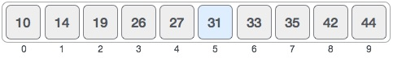

First, we shall determine half of the array by using this formula −

mid = low + (high - low) / 2

Here it is, 0 + (9 - 0 ) / 2 = 4 (integer value of 4.5). So, 4 is the mid of the array.

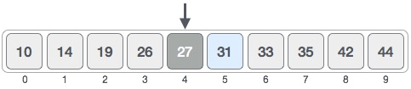

Now we compare the value stored at location 4, with the value being searched, i.e. 31. We find that the value at location 4 is 27, which is not a match. As the value is greater than 27 and we have a sorted array, so we also know that the target value must be in the upper portion of the array.

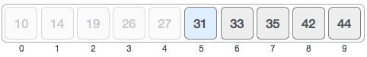

We change our low to mid + 1 and find the new mid value again.

low = mid + 1

mid = low + (high - low) / 2

Our new mid is 7 now. We compare the value stored at location 7 with our target value 31.

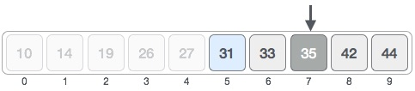

The value stored at location 7 is not a match, rather it is more than what we are looking for. So, the value must be in the lower part from this location.

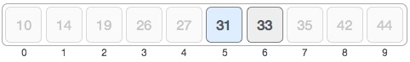

Hence, we calculate the mid again. This time it is 5.

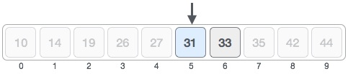

We compare the value stored at location 5 with our target value. We find that it is a match.

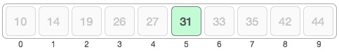

We conclude that the target value 31 is stored at location 5.

Binary search halves the searchable items and thus reduces the count of comparisons to be made to very less numbers.

Bubble sort

Bubble sort is a simple sorting algorithm. This sorting algorithm is comparison-based algorithm in which each pair of adjacent elements is compared and the elements are swapped if they are not in order. This algorithm is not suitable for large data sets as its average and worst case complexity are of Ο(n2) where **n** is the number of items.

How Bubble Sort Works?

We take an unsorted array for our example. Bubble sort takes Ο(n2) time so we're keeping it short and precise.

Bubble Sort

Bubble sort starts with very first two elements, comparing them to check which one is greater.

Bubble Sort

In this case, value 33 is greater than 14, so it is already in sorted locations. Next, we compare 33 with 27.

Bubble Sort

We find that 27 is smaller than 33 and these two values must be swapped.

Bubble Sort

The new array should look like this −

Bubble Sort

Next we compare 33 and 35. We find that both are in already sorted positions.

Bubble Sort

Then we move to the next two values, 35 and 10.

Bubble Sort

We know then that 10 is smaller 35. Hence they are not sorted.

Bubble Sort

We swap these values. We find that we have reached the end of the array. After one iteration, the array should look like this −

Bubble Sort

To be precise, we are now showing how an array should look like after each iteration. After the second iteration, it should look like this −

Bubble Sort

Notice that after each iteration, at least one value moves at the end.

Bubble Sort

And when there's no swap required, bubble sorts learns that an array is completely sorted.

Bubble Sort

Selection Sort

Selection sort is a simple sorting algorithm. This sorting algorithm is an in-place comparison-based algorithm in which the list is divided into two parts, the sorted part at the left end and the unsorted part at the right end. Initially, the sorted part is empty and the unsorted part is the entire list.

The smallest element is selected from the unsorted array and swapped with the leftmost element, and that element becomes a part of the sorted array. This process continues moving unsorted array boundary by one element to the right.

This algorithm is not suitable for large data sets as its average and worst case complexities are of Ο(n2), where **n** is the number of items.

How Selection Sort Works?

Consider the following depicted array as an example.

Unsorted Array

For the first position in the sorted list, the whole list is scanned sequentially. The first position where 14 is stored presently, we search the whole list and find that 10 is the lowest value.

Selection Sort

So we replace 14 with 10. After one iteration 10, which happens to be the minimum value in the list, appears in the first position of the sorted list.

Selection Sort

For the second position, where 33 is residing, we start scanning the rest of the list in a linear manner.

Selection Sort

We find that 14 is the second lowest value in the list and it should appear at the second place. We swap these values.

Selection Sort

After two iterations, two least values are positioned at the beginning in a sorted manner.

Selection Sort

The same process is applied to the rest of the items in the array.

Following is a pictorial depiction of the entire sorting process −

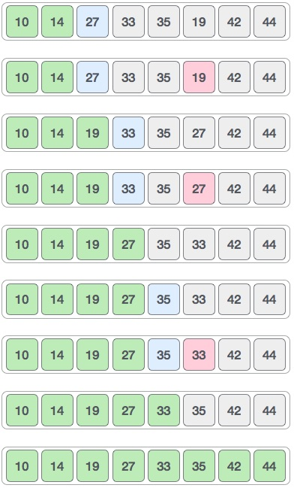

Insertion sort

This is an in-place comparison-based sorting algorithm. Here, a sub-list is maintained which is always sorted. For example, the lower part of an array is maintained to be sorted. An element which is to be 'insert'ed in this sorted sub-list, has to find its appropriate place and then it has to be inserted there. Hence the name, **insertion sort**.

The array is searched sequentially and unsorted items are moved and inserted into the sorted sub-list (in the same array). This algorithm is not suitable for large data sets as its average and worst case complexity are of Ο(n2), where **n** is the number of items.

How Insertion Sort Works?

We take an unsorted array for our example.

Unsorted Array

Insertion sort compares the first two elements.

Insertion Sort

It finds that both 14 and 33 are already in ascending order. For now, 14 is in sorted sub-list.

Insertion Sort

Insertion sort moves ahead and compares 33 with 27.

Insertion Sort

And finds that 33 is not in the correct position.

Insertion Sort

It swaps 33 with 27. It also checks with all the elements of sorted sub-list. Here we see that the sorted sub-list has only one element 14, and 27 is greater than 14. Hence, the sorted sub-list remains sorted after swapping.

Insertion Sort

By now we have 14 and 27 in the sorted sub-list. Next, it compares 33 with 10.

Insertion Sort

These values are not in a sorted order.

Insertion Sort

So we swap them.

Insertion Sort

However, swapping makes 27 and 10 unsorted.

Insertion Sort

Hence, we swap them too.

Insertion Sort

Again we find 14 and 10 in an unsorted order.

Insertion Sort

We swap them again. By the end of third iteration, we have a sorted sub-list of 4 items.

Insertion Sort

Merge sort

Merge sort is a sorting technique based on divide and conquer technique. With worst-case time complexity being Ο(n log n), it is one of the most respected algorithms.

Merge sort first divides the array into equal halves and then combines them in a sorted manner.

How Merge Sort Works?

To understand merge sort, we take an unsorted array as the following −

Unsorted Array

We know that merge sort first divides the whole array iteratively into equal halves unless the atomic values are achieved. We see here that an array of 8 items is divided into two arrays of size 4.

Merge Sort Division

This does not change the sequence of appearance of items in the original. Now we divide these two arrays into halves.

Merge Sort Division

We further divide these arrays and we achieve atomic value which can no more be divided.

Merge Sort Division

Now, we combine them in exactly the same manner as they were broken down. Please note the color codes given to these lists.

We first compare the element for each list and then combine them into another list in a sorted manner. We see that 14 and 33 are in sorted positions. We compare 27 and 10 and in the target list of 2 values we put 10 first, followed by 27. We change the order of 19 and 35 whereas 42 and 44 are placed sequentially.

Merge Sort Combine

In the next iteration of the combining phase, we compare lists of two data values, and merge them into a list of found data values placing all in a sorted order.

Merge Sort Combine

After the final merging, the list should look like this −

Merge Sort